*Yorkshire & The Humber Regional Transfusion Committee*



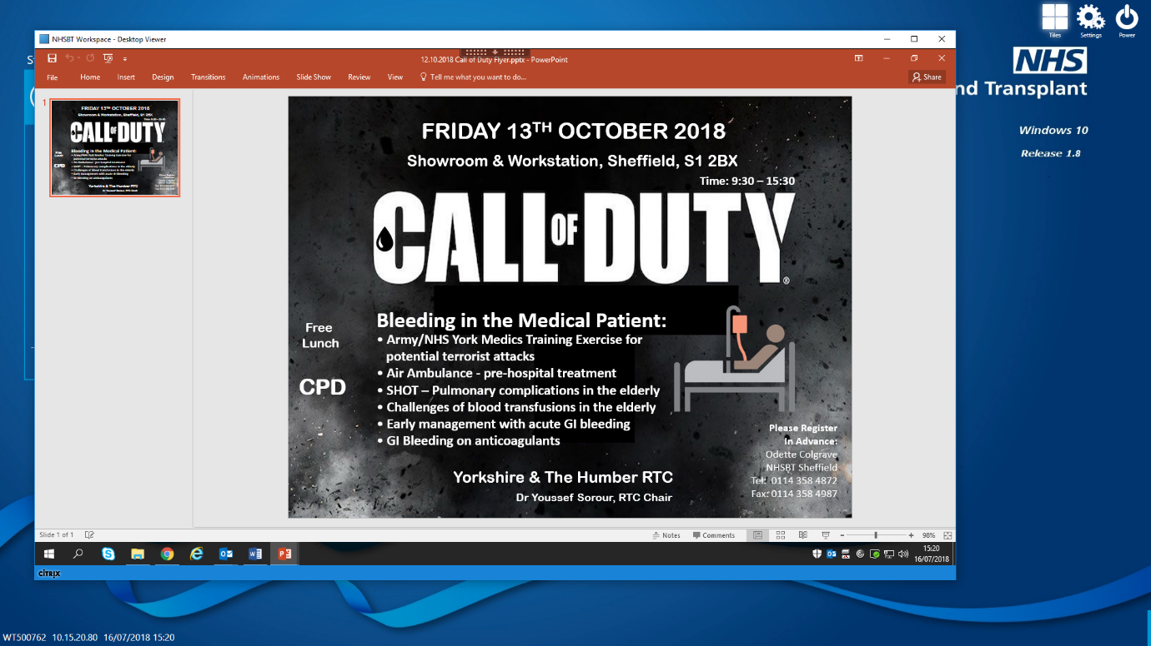

Venue: Showroom & Workstation

15 Paternoster Row

Sheffield S1 2BX

**Friday 12th October 2018**

Application Form

I wish to attend “Call of Duty” on Friday 12th October 2018:

(Please use capitals)

|  |
| --- |
| Name: |
|  |
| Job Title: |
|  |
| Hospital & Address: |
|  |
| Telephone: |
|  |
| Email: |
|  |
| Special Dietary Requirements: |

Please return by Friday 28th September 2018 to:

*Odette Colgrave*

*RTC Administrator*

*NHSBT, Longley Lane, Sheffield S5 7JN*

*Tel: 0114 358 4872*

*Email:odette.colgrave@nhsbt.nhs.uk*

Visit the website for Yorkshire & The Humber RTC information:

<http://www.transfusionguidelines.org.uk/uk-transfusion-committees/regional-transfusion-committees/yorkshire-humber>

Al Although this event is free, we are still charged for the catering for non-attendees. Please advise

us if you are unable to attend at the earliest convenience.

Failure to do so will automatically place you on the reserve list for future events

Your personal information you have provided will be used to allocate you a space at this event and to communicate with about this event ONLY.   After this event, the application form and subsequent contact details will be destroyed.  However, should you wish to be kept informed of future RTC events then please tick here Yes  No

We will remove all contact details upon request at any time; please contact the RTC Administrator who will action this accordingly.