Worthing Health Education Centre, BN11 2HR
By Train:
Worthing station is a 10 minute walk from the hospital or there is a taxi rank. A direct service runs to Worthing from Brighton, and London, Victoria. (If you are travelling from London – it is no quicker to go to Brighton and then change for Worthing – try to take a direct train to Worthing).

By Car:
Approach Worthing either via the A24 or A27. Follow the A24 south into Worthing, over the railway line bridge, turn left at the roundabout along Newland Road, continue on to Chesswood Road, turn right on to Homefield Road, then turn right again on to Park Avenue, the WHEC is ½ way along on your left.

Car Parking:
Unfortunately we do not have any parking facilities at the moment. Delegates for conferences and meetings need to use the main hospital car park. The entrance to the public car park is on the left of the approach road that leads from Lyndhurst Road to the main entrance of the Hospital. Take your ticket at the entrance and do not leave it in your car. To leave the car park you will need to produce your ticket to pay the appropriate charge at the pay machines in order to get an exit ticket to raise the exit barrier.

Health Education Centre:
The main entrance to the Centre is in Park Avenue and not via the Hospital Main Entrance. It is only a short walk around the corner, up Homefield Road and next left along Park Avenue.

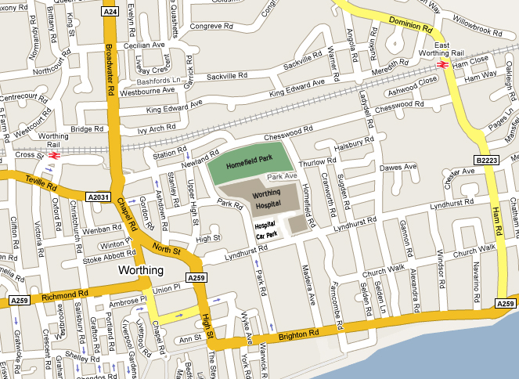
Worthing Health Education Centre

