**MUMS, BABIES & BLOOD**

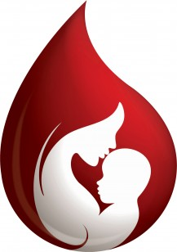

**A transfusion education event for midwives in the East of England to be held at the Hallmark Hotel, Bar Hill Cambridge**

Thursday 28th June 2018. Registration from 9.15 am, close 3.30 pm*

APPLICATION FORM

First Name: Last name

Hospital:

Department:

Position:

E-mail address:

Telephone:

Special dietary requirements:

* **Please note that the programme for this event is very similar to Mums, Babies & Blood held in previous years.**
* **Places will be confirmed only on receipt of application form and delegate fee. Closing date for applications Thursday 21st June 2018.**

**All applications received are acknowledged; please do not assume you have a place without confirmation.**

**\* Please note start and finish times. Attendance certificates will be distributed at close.**

**DELEGATE FEE £20**

**Contact Jane O’Brien for debit card payment details**

Please return completed forms to:

Jane O’Brien,

RTC Administrator

NHSBT

Long Road

Cambridge. CB2 0PT

Telephone: 01223 588906

E-mail: jane.o’brien@nhsbt.nhs.uk

jane.o’brien6@nhs.net