**Background**

WNV is an arthropod borne flavivirus, first isolated in 1937 and widely distributed in Africa, Western Asia, Europe and Australia. The principal vectors are mosquitoes and the principal hosts are wild birds. Humans and other animals e.g. horses, are infected via mosquito bites. They are considered to be "incidental hosts" as they do not develop sufficient viraemia to maintain transmission cycles. The incubation period of WNV in humans is reported to be 3-15 days. Most human infections are either asymptomatic (76%), or result in only mild flu-like symptoms with full recovery (24%), but 1 in 150 to 200 infected individuals may develop a more severe form of the disease which may culminate in fatal encephalitis, particularly if elderly or immunosuppressed.

**WNV in the US and Canada**

WNV emerged for the first time in the Northeast of the United States (US) in 1999. WNV case numbers increased in the US in following years, and WNV is now found across the whole of the US and into Canada. WNV cases in the US peaked in 2003 with 9858 human cases and 262 deaths. Thereafter there was a steady decline in cases until 2009 (663 human cases, 30 deaths and 109 presumptive viraemic blood donors). With the exception of 2012, in which the highest number of WNV cases since 2003 was reported (5387 human cases, 243 deaths, 597 presumptive viraemic blood donors), the number of WNV cases has remained relatively constant with the number of presumptive viraemic blood donors identified also remaining constant and high. In Canada a similar pattern has been seen. The majority (99%) of the human cases currently occur between 1st July and 31st October each year.

As travel to the USA and Canada is common in UK blood donors (although not currently due to the COVID-19 pandemic), a deferral policy for such donors was adopted by UK Blood Transfusion Services in June 2003 as a precautionary measure.

**WNV in Europe**

In Europe, sporadic WNV outbreaks have occurred in Romania (1996 and 2008), Russia (1999), Israel (2000) and Hungary (2008). During 2010, human cases were reported in a number of European countries, including Hungary, Spain, Italy, Greece, Romania and Russia. Whereas WNV lineage 1 is the circulating genotype in the US, both lineage 1 and lineage 2 are circulating in Europe and the importance of the presence of both lineages in Europe needs to be better understood. Further WNV outbreaks in an increasing number of areas within Europe in 2010/11 led to the recommendation for WNV NAT testing in the "WNV Preparedness Plan" in order for countries to maintain a sufficient blood supply and a number introduced WNV NAT testing.

Monitoring of cases of WNV with weekly surveillance updates is carried out by the European Centre for Disease Prevention and Control (ECDC) (Table 1, Figure 1). Distribution of outbreaks in equids and/or birds are also monitored to indicate areas at risk for human WNV infections.

**Table 1: WNV cases in EU and EEA surrounding countries by year**

|  |  |  |
| --- | --- | --- |
| **Year** | **Cases in EU/EEA countries** | **Cases in surrounding countries** |
| 2011 | 128 | 212 |
| 2012 | 242 | 693 |
| 2013 | 228 | 557 |
| 2014 | 75 | 136 |
| 2015 | 122 | 193 |
| 2016 | 226 | 267 |
| 2017 | 201 | 84 |
| 2018 | 1549 | 580 |
| 2019 | 425 | 53 |
| 2020 | 319 | 17 |
| 2021 (to Oct 14th 2021) | 132 | 18 |

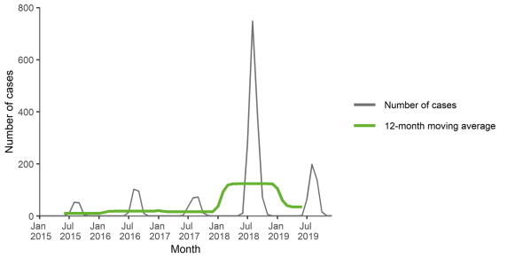

**Figure 1:** **Distribution of locally acquired WNV infections by month in EU/EEA, 2015-2019 (Taken from ECDC West Nile virus, Annual Epidemiological Report for 2019)**

After a sharp increase in WNV infections in Europe in 2018 (a year in which infection numbers exceeded the total number from the previous seven years) numbers of reported WNV infections decreased again in 2019, 2020 and 2021 in most countries. The exceptions were Greece, where numbers remained high and Cypress which reported 23 locally acquire infections in 2019 (having only reported one infection in 2016 and 2018).

Between 2018 and 2020, France, Slovakia, Germany, Spain and the Netherlands reported their first locally acquired WNV infections although overall number of cases reported in Europe in 2020 was down on previous years. In 2020, the first European WNV case was reported in June (disease onset in week 23, between 1 and 7 June) and the last case was reported in November (disease onset in week 43, 19 to 25 October).

Since the beginning of the 2021 transmission session and as of 14th October 2021, EU/EEA countries have reported 132 human cases of WNV infection with most cases reported in Greece 943) and Italy (27). EU-neighbouring countries have reported 18 human cases of WNV infection in Serbia (18).

In 2017, seven Austrian blood donors from Austria were reactive for WNV during blood screening. However, follow-up investigations revealed that six of these were in fact infected with a related virus, Usutu virus (USUV). Since then WNV blood donor screening/research studies have identified USUV infections in blood donors in Austria, Italy, Germany and the Netherlands.

**Transmission through donated products**

During the 2002 epidemic in the USA 23 patients were confirmed to have acquired WNV through transfusion of red cells, platelets or fresh frozen plasma. A case of transfusion-transmitted WNV infection from an MP-NAT non-reactive donation collected just before triggering conversion to ID-NAT was reported in the US in 2016. This was deemed a rare event recognised once in 84 million donations.

A European risk model (EUFRAT) allows the calculation of an estimated number of infected blood products (throughout Europe) from donors that were infected whilst travelling to outbreak-affected areas in Europe. Even using data from the year of highest incidence (2018) it was estimated that non-compliance to European regulations (donor testing or deferral) would have resulted in 7.4 (95% CI 4.7 -11.1) infected blood components from infected travelling donors throughout Europe (Garzon Jimenez et al., 2021). Therefore, the risk of transmission through infected blood components in the UK from travelling donors is extremely low. The risk of WNV transmission by a local outbreak was two orders of magnitude higher (113 times) than transmission by travelling donors.

Transmission has also been reported following organ transplantation from a donor who initially acquired the infection through a blood transfusion. Several reports indicate that WNV transmission through solid organ transplantation can occur from donors who are seropositive for WNV (IgM and IgG antibodies) and WNV NAT negativebut there had been no such reports of transmission from blood donations. In general, the risk of transmission by transfusion relates to a few days of viraemia starting 1-3 days after infection. Viraemia lasts a mean of 6 days although can take up to 104 days to clear.

**WNV in the UK**

There have been several human WNV cases reported in the UK. In 2006 a member of the armed forces stationed in Canada was diagnosed with WNV infection on his return to the UK and in 2007 a Canadian resident became ill when visiting the UK. The first two cases of imported WNV in Scotland were reported in 2014, both from endemic countries outside the EU. In 2017, one case of WNV was imported into the UK (out of South Africa), four in 2018 (out of Hungary and North America) and one case in 2019. No indigenous cases of WNV have been reported in the UK (HAIRS risk assessment, accessible at: [Qualitative assessment of risk West Nile virus presents to UK health (publishing.service.gov.uk)](https://assets.publishing.service.gov.uk/government/uploads/system/uploads/attachment_data/file/944318/EI_Risk_assessment_WNV_Dec_2020.pdf)

In 2010 the mosquito *Culex modestus,* largely responsible for transmission of WNV between birds, horses and humans, in Southern Europe, was reported in the UK. The map below shows where these mosquitoes have been detected. To date *C. modestus* has not been detected elsewhere in England.

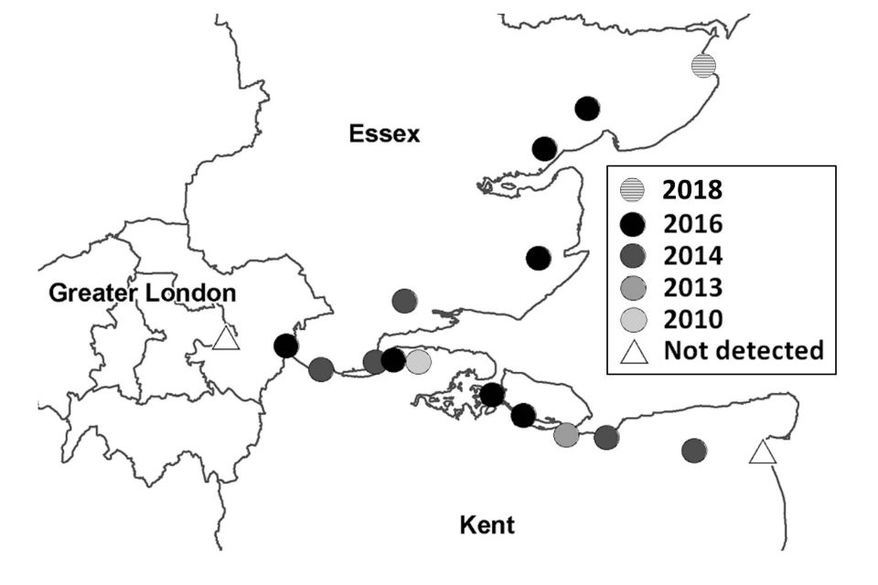

Figure 2: Map showing known distribution of *Culex modestus* mosquitoes in south-east England accessible at: [West Nile virus: epidemiology, diagnosis and prevention - GOV.UK (www.gov.uk)](https://www.gov.uk/guidance/west-nile-virus)

Since the UK Blood Transfusion Services implementation of WNV NAT testing for blood donors with relevant travel history (2012-2013), no donors have been found to be positive for WNV RNA (more than 296 000 donors tested).

**UK Blood Transfusion Services WNV risk reduction strategies**

The EU Blood Safety Directive (and the Blood Safety and Quality Regulations) requires that travellers from an area with ongoing transmission of WNV in humans should be deferred for 28 days. Originally there was no provision within the Directive for WNV NAT testing in place of deferral, as a strategy for travellers returning from an affected area. The directive became UK statutory law as the Blood Safety and Quality Regulations 2005. Thereafter UK Blood Transfusion Services deferred travellers returning from areas at risk* of WNV. In 2012 a review of the "WNV Preparedness Plan" agreed that WNV NAT testing could be applied by blood establishments in non-affected areas to donations from travellers returning within 28 days from an affected area, if donor deferral would threaten the sufficiency of the blood supply. A 2014 amendment to the EU Blood Safety Directive supported this stance.

**\*A WNV risk** area is defined as:

* any part of North America (USA and Canada) or any other area with ongoing transmission of WNV ("affected area") that does not attract a malaria travel deferral of 4 months and which meets the definition accepted by the European Commission/ European Centre for Disease Control.

The WNV risk period is defined as:

* between 1st May and 30th November

Donors with a history of WNV and/or a positive WNV NAT should be temporarily deferred pending investigation but may be returned to the donor panel 6 months after pick-up without the need for any further testing.

Fresh Frozen Plasma and Octaplas, imported for use within the UK, are subject to pathogen reduction methods *(*methylene blue or solvent detergent treatment). Methylene blue treatment has been shown to reduce the WNV load by at least 6.510 logs to below the detection limit therefore the risk of transmission of WNV by methylene blue treated FFP of non-UK origin must therefore be considered negligible. WNV appears to be one of the most rapidly inactivated viruses studied therefore although no specific inactivation data is available for WNV inactivation by SD treatment, other enveloped viruses such as HCV and HIV have been shown to be inactivated by >510 and>610 logs respectively, therefore SD treatmentshould also provide protection against West Nile virus.

Countries affected by WNV and any applicable time limits are shown in the Geographical Disease Risk Index (GDRI) and any associated Change Notifications.

Information about international outbreaks of WNV is available on the National Travel Health Network and Centre (NaTHNaC) website: <http://travelhealthpro.org.uk>