Policy for the provision of

Intraoperative Cell Salvage

Author:

Policy ratified by:

Responsible Officer: | Signature:
Date: | Insert Date

Classification: | Clinical | Date Issued:
Area Applicable: |  | Review Date:
Ref No: |  | Version No:

Disclaimer

When using this document please ensure that the version you are using is the current, in date version by checking on your Organisation’s database for any new versions. If the review date has passed please contact the author.

OUT OF DATE POLICY DOCUMENTS MUST NOT BE USED

Original generic policy written by the UK Cell Salvage Action Group

Guidance

All references to Intraoperative Cell Salvage (ICS), Postoperative Cell Salvage (PCS) and combined systems (ICS/PCS) in this policy, relate to WASHED systems only (unless otherwise stated).

This policy does not relate to the use of unwashed cell salvage systems e.g. postoperative autologous wound drains or combined unwashed ICS/PCS devices.

This policy has been written to support the implementation and use of washed ICS. It may also be applicable when washed ICS devices are used in the pre and/or postoperative environment (e.g. Accident and Emergency, recovery, ward etc) and for devices specifically designed for combined washed ICS/PCS.
Contents

1 | Introduction | Page 3
2 | Policy Statement | Page 4
3 | Aims | Page 5
4 | Objectives | Page 6
5 | Responsibilities | Page 7
6 | Training | Page 9
7 | Indication and Patient Selection | Page 11
8 | Contraindication and Warnings | Page 12
9 | Patient Information | Page 14
10 | Conditions for Use | Page 15
11 | Management of Massive Reinfusion | Page 19
12 | Quality Assurance | Page 20
13 | Adverse Event Reporting | Page 22
14 | Resources | Page 23
15 | Implementation | Page 24
16 | Acknowledgements | Page 25
17 | References | Page 26
Appendix I | Audit Proforma | Page 28
Appendix II | Intra-operative Cell Salvage Competency Assessment Workbook | Page 29
Appendix III | Guidance for the use of Intra-operative Cell Salvage in Obstetrics | Page 30
Appendix IV | “Please Ask About Cell Salvage” Patient Information Leaflet | Page 35
Appendix V | Manufacturers’ Guidelines | Page 36
Appendix VI | Autologous Transfusion Label | Page 37
Appendix VII | Fault Log | Page 38
Appendix VIII | “Will I need a Blood Transfusion?” Patient Information Leaflet | Page 39

1 Introduction

Whilst allogeneic (donated) blood is an essential adjunct to health care, it is an expensive and limited resource (subject to the threat of future shortages) and can present a source of risk for patients, in particular the risk of “wrong blood” incidents as reported by the Serious Hazards of Transfusion (SHOT)¹ scheme.

The Health Service Circular (HSC), “Better Blood Transfusion: Safe and Appropriate Use of Blood” (2007) and subsequent National Blood Transfusion Committee publication, “Patient Blood Management: An evidence-based approach to patent care” (2014, England only) recommend that in order to make transfusion safer, provide better information for patients, avoid inappropriate blood transfusion and to ensure the best treatment, the patient must be at the heart of decisions made about blood transfusion²⁻³.

Both publications recommend that effective alternatives to allogeneic blood transfusion be explored, including the appropriate use of autologous blood transfusion techniques such as Intraoperative Cell Salvage (ICS).

ICS is used routinely in some areas of surgical practice. The technique involves aspirating blood lost within the surgical field into a collection reservoir. Blood is mixed with an anticoagulant solution containing either heparin or citrate to prevent clotting. A modified aspiration line is used to deliver the anticoagulant to the tip of the suction. As blood enters the collection reservoir it is filtered to remove large particulate debris. The salvaged blood is then centrifuged and washed to produce red blood cells suspended in saline for reinfusion to the patient. The waste products (plasma, platelets, anticoagulant etc) are removed during processing and the washed red blood cells are transferred to a reinfusion bag. When used appropriately, by adequately trained staff, ICS is a simple, safe and cost-effective method of reducing allogeneic transfusion⁴.

2 Policy Statement

Utilising appropriate alternatives to blood transfusion is cost-effective and complies with clinical governance requirements.

The collection and re-infusion of autologous red blood cells provides an important contribution to reducing the demand for allogeneic blood. However, it is only one aspect of a strategic approach to safe and appropriate transfusion practice.

3 Aims

The aim of this policy document is to provide information that will allow clinicians to:

- Utilise ICS in a safe and effective manner.

- Safely identify suitable patients undergoing elective and / or emergency surgical procedures where ICS could be used.

4 Objectives

The objectives of this policy are to provide a rational and practical framework on which to maximise patient safety during ICS by:

- Promoting safer transfusion as part of clinical governance responsibilities.

- Assisting clinical staff in the identification of patients and procedures considered suitable for ICS and outlining the indications and contraindications.

- Assisting clinical staff to provide appropriate advice on options for treatment, particularly where patients are anxious about risks associated with donor blood.

- Providing clear written information about the risks and benefits of autologous transfusions from blood salvaged intraoperatively.

- Assisting clinical staff to minimise avoidable/potential risks of autologous transfusions from blood salvaged intraoperatively.

5 Responsibilities

The Organisation should define individual responsibilities and identify a clinical lead for the ICS programme.

Responsibilities associated with ICS include:
- Prescribing responsibilities.
- Labelling responsibilities.
- Individual responsibilities.
- Documentation responsibilities.

Prescribing Responsibilities
Salvaged blood reinfusion should be prescribed / authorised by the responsible clinician on the documentation approved by the Organisation.

Labelling Responsibilities
The reinfusion bag should be labelled as soon as is reasonably practical (i.e. when the patient is in theatre or as soon as the processing set is loaded if a “collect only” system has been used initially). If a “collect only” system has been set up, it is recommended as best practice that the collection reservoir is labelled, this label can then be transferred to the reinfusion bag when the processing set is loaded. The patient details should be handwritten on the label from the patient’s identification band (attached to the patient) and include the following:
- Full name.
- Date of birth.
- Unique identification number.
- Expiry date and time of the salvaged blood.
- The statement “Untested Blood –“For Autologous Use Only”¹¹.

Addressograph labels should not be used because of the known associated risks⁵.

Individual Responsibilities
Individual staff should ensure that they are adequately trained and competent in the use of the ICS system and their individual responsibilities according to their area of work i.e. operator, anaesthetic, scrub, recovery and ward staff. Individual staff should ensure they are adequately trained and competent in the use of ICS in each of the specialities they work in. Staff should not use equipment for which they have not been trained and competency assessed.

Documentation Responsibilities
Staff should ensure that documentation (including all appropriate labelling) accurately reflects the ICS process. The documentation record should include:
- The ICS audit form (Appendix I).
- The autologous transfusion label should be completed and attached to the reinfusion bag.
- At the time of reinfusion of the salvaged blood, the peel out section on the autologous transfusion label should be completed and attached in the appropriate place in the patient’s clinical records or equivalent as specified in the Organisations Transfusion Policy (Policy Document Ref No. for the Organisation’s Transfusion Policy should be entered here).
- Appropriate labelling of heparin saline anticoagulant or citrate (ACD-A) at the start of the procedure.
- Bedside pre-transfusion checks and patient observations prior to and during ICS blood reinfusion should be performed and recorded in the same way as for the transfusion of allogeneic blood (Policy Document Ref No. for the Organisation’s Transfusion Policy should be entered here). Additional observations are at the discretion of the clinical staff based on an individual patient assessment.
- Adverse incidents should be documented in the patient’s clinical records and reported as in section 13.
6 Training

- Key personnel should be identified in each clinical area as a contact for communication and training. This person will maintain training records of staff who have received training in the use of the ICS device (a copy of this record may be sent to the Transfusion Practitioner or other designated person (specify) for central collation).

- Theoretical and practical training should be undertaken and staff should be competency assessed before they set up or operate ICS equipment without supervision.

- Individual staff should receive training in the indications, contraindications and technical differences specific to their speciality/specialities. If a member of staff moves from one speciality to another, it is good practice for training needs to be identified and addressed prior to the staff member using ICS in their new clinical environment.

- Staff carrying out ICS for Jehovah’s Witness patients should have received training and have been competency assessed in preparing the equipment and blood for reinfusion in accordance with the patients’ religious beliefs, prior to carrying out the procedure.

- An ICS Competency Assessment Workbook is available via the Transfusion Practice section of the JPAC website, at: www.transfusionguidelines.org.uk (see also Appendix II). It is strongly recommended that once assessed as competent, individuals keep an ongoing log (similar to that in the ICS Competency Assessment Workbook) of all the ICS procedures they carry out.

- Operators have a professional responsibility / accountability to ensure they are up to date and competent in relation to their practice. Organisations may also wish to include the following wording in their policy based on a risk assessment: In order to maintain operator competency there is a maximum period of (specify) permitted between procedures / minimum number of (specify) procedures in a (specify) time period (delete as appropriate) before re-training/assessment is required.

- Update training is recommended under the following circumstances:
- Any reasonable length of time without practical use of the ICS device.
- A learning need is identified by an individual member of staff or supervisor.
- Changes in the product from the manufacturer or a change in the product due to the Organisation trialling/purchasing new products.
- Changes to national and/or local guidelines relating to any aspect of autologous transfusion (including changes to the Organisation’s Blood Transfusion Policy).
- Following an incident or error.

Individual Responsibilities
Individual staff should ensure that they are adequately trained and competent in the use of the ICS system used and their individual responsibilities according to their area of work, i.e. operator, anaesthetic, scrub, recovery and ward staff.

- Indications and Patient Selection

- Cell salvage is indicated in any surgical procedure, either planned or urgent, where the benefit results in the reduction or complete avoidance of allogeneic red cell transfusion.

Procedure related factors:
  - Anticipated blood loss is > 1000ml or > 20% circulatory volume.
  - Procedures where >10% of patients require an allogeneic transfusion.
  - The mean transfusion for the procedure exceeds one unit of allogeneic red cells.

Patient related factors:
- Refusal of allogeneic blood.
- Difficulty in obtaining compatible allogeneic blood.
- Patients with a low haemoglobin.
- Increased risk of bleeding.

Each patient presenting for surgery will have a greater or lesser risk of bleeding and consequently a varying threshold for requiring a transfusion. Any decision to use cell salvage should therefore be made on an individual patient basis.

- ICS systems may be used in elective and/or emergency surgical procedures where the surgical field is not contaminated by faecal or infective matter and where no other contraindications exist (see section 8).

- Patient selection for ICS is at the discretion of the surgeon and anaesthetist caring for the patient.

- If the surgical procedure to be carried out is associated with any of the contraindications as listed in section 8, the potential risks and hazards should be discussed with the patient and their agreement to undergo ICS documented in the patient’s clinical records.

8 Contraindications and Warnings

The risk/benefit ratio of ICS should be assessed for each individual patient by the surgeon and anaesthetist responsible for the patient’s care.

Contraindications
ICS should not be used in the following situations:
- Bowel contents in the surgical field.
- Heparin induced thrombocytopenia when heparin is the anticoagulant of choice (a citrate containing anticoagulant solution may be used instead).

Warnings
- ICS should be temporarily discontinued when substances not licensed for Intravenous (IV) use are used within the surgical field and could potentially be aspirated into the collection reservoir. The standard theatre suction should be used to aspirate the surgical field and the wound should be irrigated with copious IV normal saline (0.9% NaCl) before resuming ICS.

Examples of non-IV materials that should not be aspirated into the ICS system include:
  - Antibiotics not licensed for IV use.
  - Iodine.
  - Topical Clotting Agents.
  - Orthopaedic Cement.

- The use of ICS in the presence of infection may result in bacterial contamination of the salvaged blood. The aspiration of blood from an infected site should be avoided and antibiotics should be given as appropriate.

- Gastric/pancreatic secretions should not be aspirated into the system as they may cause enzymatic haemolysis and are not reliably removed by the washing procedure.

- Pleural effusions should not be aspirated and should be drained prior to cell salvage. However, blood which subsequently accumulates in the pleural space may be aspirated.

- There are concerns relating to the use of ICS in patients with sickle cell disease. The use of ICS in patients with abnormal red cell disorders should be made on a clinical, individual patient basis taking the latest evidence into account.

- Amniotic fluid should theoretically not be aspirated into the system, due to the risk of Amniotic Fluid Embolism (National Institute for Health and Care Excellence [NICE]) and should be removed by separate suction prior to starting cell salvage. See Appendix III for obstetric ICS usage.

- The use of ICS in patients undergoing surgery for malignant disease is not recommended by the manufacturers of ICS devices. This is due to concern about the possibility of malignant cells being reinfused and giving rise to metastases. However, there are now a number of reports in the literature of the use of ICS in cancer surgery without obviously leading to early metastasis⁷⁻⁹ and some hospitals now use ICS routinely during surgery for malignant disease. Aspiration of blood from around the tumour site should be avoided to minimise contamination of salvaged blood with malignant cells and the salvaged blood may be reinfused through a leukocyte reduction filter to minimise the reinfusion of any malignant cells which may have been aspirated into the collection reservoir.

Guidance on the use of ICS in radical prostatectomy and radical cystectomy is available from NICE¹⁰.

The decision to use ICS in the presence of malignant disease should be made by the surgeon and anaesthetist in consultation with the patient.

Cautions
- The use of Hartmann’s Solution will inhibit the action of citrate based anticoagulants (e.g. ACD) if used as an irrigant or wash solution.

- Air will be present in the primary reinfusion bag when it is still connected to the cell salvage device or when it has been disconnected but air has not been evacuated. Where possible, all air should be evacuated from the primary reinfusion bag prior to reinfusion. Manufacturers advise NOT to use a pressure cuff as there is a risk of air embolus and some devices may also detect a back pressure if the reinfusion line is open.

- Manual mode – It is recommended that ICS devices are not run in manual mode as this may lead to reduced quality, insufficient washing of the final red blood cell product and the possible reinfusion of potentially harmful contaminants e.g. heparin. ICS devices should be run in automatic mode wherever possible. Manual mode should only be used when the benefits of doing so outweigh the risks e.g. emergency situations where the need to reinfuse the red cells quickly outweighs the risks associated with running the device in manual mode.
9 Patient Information

- Patients considered likely to have ICS during planned surgery should receive information about ICS before their operation. The process should be discussed with the patient pre-operatively whenever possible and the discussion documented in the patient’s clinical records. Written information may be useful – for example the Patient Information Leaflet “Please Ask About Cell Salvage” (Appendix IV).

- For patients undergoing emergency surgery, the use of ICS is at the discretion of the surgeon and anaesthetist responsible for the patient’s care when it cannot be discussed with the patient prior to surgery.
10 Conditions for Using ICS

Use of the ICS Equipment
- The ICS system should be used in accordance with the manufacturer’s guidelines (Appendix V).

- All procedures should be carried out in accordance with the hospital’s ICS policy and procedural documents.

- The ICS system should be routinely run in automatic mode (see Cautions - section 8).

- Contraindications should be considered as identified in Section 8.

- All staff that set up or operate ICS systems should receive theoretical and practical training (see section 6) and should have completed the ICS Competency Assessment Workbook (Appendix II).

- Staff should comply with hospital policies for infection control, management of sharps and blood transfusion.

- Clean / non-touch / aseptic technique should be used as appropriate, to reduce the risk of infection.

Anticoagulant
- The type of anticoagulant used should be documented in accordance with organisational policy (Organisations Policy Ref No. should be entered here).

- Anticoagulant prepared by the operator (e.g. heparin saline) should be labelled clearly to avoid error.

Wash Solution
- IV normal saline (0.9% NaCl) should be used as the wash solution.

- The minimum wash volume, as outlined in the manufacturers’ guidelines (Appendix V) for the size of the centrifuge bowl in use and the type of surgical procedure, should be used in all but the most urgent situations.

Swab Washing
- Blood soaked swabs should be soaked in IV normal saline (0.9% NaCl).

- Gently compress the swabs to express any residual solution before discarding.

- Aspirate the swab wash solution into the cell salvage reservoir using the suction line.

- Consider evacuating the swab wash every 2 hours to avoid stagnation; it should not be left for more than 6 hours without processing.

Labelling
- All salvaged blood should be labelled.

- Labels should be handwritten. Pre-printed “addressograph” labels should not be used.

- Labelling information should include:
  - Full name.
  - Date of birth.
  - Unique identification number.
  - Expiry date and time of the salvaged blood.
  - The statement “Untested Blood – For Autologous Use Only”¹¹.

    - To avoid errors in patient identification, an autologous transfusion label, such as that in appendix VI, should be completed at the patient’s side when the patient has arrived in theatre i.e. the reinfusion bag should not be pre-labelled prior to the patient’s arrival in theatre or labelled after the patient has left theatre. The patient’s details must be taken from the identification band attached to the patient and not from any clinical records or charts that may be present in the operating theatre. All fields on the label should be completed in full.

    - If the system has been set up as a “collect only” system (collection reservoir and aspiration and anticoagulant line only), the collection reservoir should be labelled in accordance with the above instructions for labelling a reinfusion bag. If a processing set is subsequently loaded into the machine, the autologous label on the collection reservoir should be transferred onto the reinfusion bag immediately or a new label completed (as above).

Re-infusion
- ICS may be set up as a “closed-circuit” system. Blood is aspirated from the surgical field, processed and transferred to a reinfusion bag. The reinfusion bag is simultaneously connected to the patients IV cannula via an appropriate filter (see below). The person administering the reinfusion adjusts the rate at which the red cells are reinfused using a clamp on the administration set and by adjusting the height of the reinfusion bag. A pressure cuff should not be applied, to increase the flow rate, because of the risk of air embolism. The same reinfusion bag may fill and empty many times during an operation.

- Alternatively, ICS may be set up without simultaneous connection of the reinfusion bag to the patient (as above). In this case, the reinfusion bag is disconnected from the ICS device when it is full or at the end of the surgical procedure and is subsequently connected and reinfused to the patient as in the “closed-circuit” system.

- A filter, appropriate to the type of surgery, should be used for reinfusion. A blood administration set containing a 200µm filter is suitable in most cases. Alternatively, a 40µm microaggregate blood filter can be used. It is recommended that a leukocyte depletion filter is used for obstetrics and malignancy cases. Lipid filters are also available which can be used for orthopaedics.

- Reinfusion of the salvaged blood should follow standard blood transfusion practice (Policy Document Ref No. for the Organisation’s Transfusion Policy should be entered here). The responsible clinician should authorise salvaged blood for reinfusion in the same manner as for allogeneic blood.

- The patient details on the reinfusion bag must be carefully checked against the details on the identification band attached to the patient before connecting the reinfusion bag to the patient. Positive Patient Identification must be confirmed prior to reinfusion commencing.

- The reinfusion of salvaged blood should be documented in the appropriate section of the patient’s clinical record or equivalent as specified in the Organisation’s Transfusion Policy (Policy Document Ref No. for the Organisation’s Transfusion Policy should be entered here). The autologous transfusion label, as in Appendix VI, contains a peel out section which should be completed at the time of reinfusion and can be used for this purpose.

Storage
- ICS blood must not be stored.

- The reinfusion bag should be kept beside the patient at all times.

- The reinfusion bag must not be placed into a refrigerator.

Expiry
- The collection, processing and reinfusion of salvaged blood should be completed within the timeframes as recommended by the manufacturer. This should be in accordance with guidance from the American Association of Blood Banks (AABB)¹¹ and the Organisation’s Transfusion Policy (Policy Document Ref No. for the Organisation’s Transfusion Policy should be entered here).

The AABB Guidelines¹¹ state the expiry times for cell salvaged blood as follows:
  - Intraoperative Cell Salvage: 4 hours from the completion of processing (applicable for both washed ICS and combined washed ICS / PCS devices during the intraoperative phase).
  - Postoperative Cell Salvage: 6 hours from the start of collection (applicable when intraoperative cell salvage devices are used to salvage blood postoperatively and for combined washed ICS / PCS devices during postoperative cell salvage).

    - For ICS, processing should begin as soon as there is sufficient blood in the collection reservoir. The expiry time is calculated as 4 hours from the completion of processing.

    - For combined washed ICS/PCS devices, two separate expiry times should be recorded using the guidance above. One for blood salvaged intraoperatively and one for blood salvage postoperatively.

    - Any blood that has not been transfused within the timeframe specified in the guidelines should be disposed of in accordance with local policy for dealing with liquid bio hazardous waste (Policy Document Ref No. should be entered here).

    - These time frames are in-use limits and not “shelf life” storage limits. ICS blood must not be stored away from the patient.

Documentation
- The collection and reinfusion of salvaged blood should be accurately documented on an appropriate form such as that in Appendix I.

- The use of a generic autologous transfusion label is recommended (Appendix VI); the peel out section of the label is completed and attached to the patient’s clinical record upon reinfusion of the salvaged blood.

- Adverse incidents and Serious Adverse Events should be documented / reported (see Section 13).

- Bedside pre-transfusion checks and patient observations prior to and during autologous blood reinfusion should be performed and recorded in the same way as transfusion of allogeneic blood - in accordance with the Organisation’s Blood Transfusion Policy (Policy Document Ref No. for the Organisation’s Transfusion Policy should be entered here). Additional observations are at the discretion of the clinical staff based on an individual patient assessment.

- The Organisation should ensure that adequate records are retained in all cases where ICS is used.

Disposal of used ICS equipment
- Following use, all ICS disposable equipment should be disposed of in accordance with the Organisation’s Health and Safety Policy for disposable of equipment contaminated with blood (Organisation’s Policy Ref No. should be entered here).

Cleaning and Disinfection of ICS Machines
- Following use, the cell salvage machine should be cleaned in accordance with the manufacturers’ guidance and the Organisation’s Infection Control Policy (Organisation’s Policy Ref No. should be entered here), including procedures for cleaning equipment following high risk cases.

- Following contamination of the equipment internally, the equipment should be removed from use, identified as a potential biohazard and referred to the manufacturer.

Maintenance of Equipment
- All ICS equipment should be serviced regularly in accordance with the manufacturer’s recommendations. A maintenance record and fault log (Appendix VII) should be kept for each machine.

  - The Management of Massive Reinfusion

As with the transfusion of large volumes of allogeneic red cells, the return of large volumes of salvaged red blood cells will coincide with the depletion of platelets and clotting factors associated with massive blood loss.

In the event of a massive reinfusion of salvaged red blood cells, it is vital to consider the need for additional appropriate transfusion support e.g. platelets, fresh frozen plasma and cryoprecipitate.

Staff should be alert to a large blood loss into the collection reservoir and report this to the surgeon and / or anaesthetist.
12 Quality Assurance

Minimum Standards for Quality Assurance and Quality Control
This document sets out the minimum recommended standards for quality control (QC) of the end product in intra-operative cell salvage (ICS). It is acknowledged that some hospitals will employ a meticulous QC process that includes laboratory style validation processes. While this may be viewed as the ‘gold standard’ for QC in ICS, it is acknowledged that others will have difficulties in achieving testing of the end product. The following fundamental elements are intended to support hospitals who wish to implement a QC process for ICS.

Key Aspects of QC in ICS
- Maintenance contracts and regular servicing of machines.
- Frequency of sampling from machines.
- Sampling methods and equipment.
- Sample labelling.
- Investigations and associated actions.
- Personnel involved.

Maintenance and Servicing
The ICS machine will have been through a series of quality checks by the manufacturer before it is released to the purchaser. It is essential that the machine is maintained and serviced to the manufacturer’s schedule to ensure reliable function. Adherence to the maintenance schedule minimises risks to the patient and operator. Therefore, as a minimum we recommend:
- All ICS machines are maintained and serviced as recommended by the manufacturer or preferably through a service contract with the manufacture

Frequency of sampling from machines
- There is some variability in frequency of use for ICS machines with some being used for multiple procedures during one day, while others may be used far less. Agree a suitable schedule with the laboratory for all machines. As a minimum we recommend:
- One sample from each machine should be tested monthly using a standard, documented procedure.
- Following servicing or changes to the machine perform a quality check during the next case or with a test sample.

Sampling Methods and Equipment
Samples should be collected from the red cell reinfusion bag prior to reinfusion. Sample tubes will be determined by the investigations you wish to conduct. Results may be adversely affected by poor sampling technique such as using a needle and vacuum tube.
- Invert the filled reinfusion bag several times to ensure adequate mixing.
- Run the salvaged red blood cells through a blood administration set with a 3-way tap at the patient end.
- Take the sample before the end of the procedure and before connection to the patient.
- To avoid haemolysis gently withdraw 10ml of blood from the reinfusion line via the 3-way tap.
- Remove the rubber stopper from the sample tube and gently transfer the blood into the tube.
- If a leucodepletion filter is used do not use a syringe; open the 3-way tap and allow the blood to run into the unstoppered tube by gravity.

Sample labelling
Establish an unambiguous method of sample labelling so that quality samples are not confused with patient blood samples.
- With the laboratory agree a method for sample labelling with clear identifiers that are linked to each machine and the patient when the sample is taken during an actual procedure.
- Record in the patient record when a quality sample is taken during the procedure.
- Clearly identify that the sample is for QC purposes and should not be acted on for patient care.

Investigations and associated actions
Samples of the end product may go through a range of investigations, some of which are intended to test the wash efficacy. These include free haemoglobin, albumin and/or heparin. Results should be within the parameters set by the machine manufacturer and to locally agreed acceptance criteria.

The minimum requirement is:
- Haemoglobin level of component: to establish the quality of the component being reinfused.
- Haematocrit level of component: to establish the quality of the component being reinfused.
- Include in the local policy the action to be taken if the machine fails the QC check e.g. remove from service.

Personnel
All staff operating ICS machines should be trained and competent to do so. Persons collecting QC samples should be authorised locally, and appropriately trained and assessed in the required techniques.
- Retain a log of locally authorised personnel that includes a record of training and assessment.
- All staff should work to a standard, documented method when taking QC samples.
13 Adverse Event Reporting

- Technical problems with the ICS device should be reported to the manufacturer.

- Serious Adverse Events must be reported to the clinical lead for ICS and the Organisation’s Transfusion Practitioner. Any adverse events relating to the ICS device must be reported in accordance with the Organisation’s Incident Reporting Policy (Organisations Policy Ref No. should be entered here). Additionally, where appropriate, reporting to the relevant external bodies should be undertaken e.g. Serious Hazards of Transfusion (SHOT), Medicine and Healthcare Products Regulatory Agency (MHRA), especially if the incident has led to, or were it to occur again could lead to, death, life-threatening illness or injury. Other minor safety or quality incidents (caused by human error) should also be reported as these can help demonstrate trends or highlight inadequate manufacturing or supply systems, instructions and / or training¹².

- Adverse events should be documented in the patients’ clinical records.

- Examples of Adverse Events include:
  - Severe reaction on reinfusion of salvaged blood.
  - Non-labelling / incorrect labelling of salvaged blood.
  - Equipment malfunction.
  - Communication failure leading to inappropriate reinfusion of the salvaged blood e.g. contamination occurred within the surgical field and this was not communicated to the operator / anaesthetist.

Reporting of ICS incidents to SHOT is encouraged. The SHOT data collection form can be downloaded at: http://www.shotuk.org/sabre/. Once completed, this should be forwarded to the Hospital Transfusion Team (insert contact details here).

14 Resources

The provision of safe ICS requires adequate resources for the formal, documented training of all staff who set up or operate the equipment and for the regular maintenance and prompt repair of all ICS equipment.

15 Implementation and Distribution of the Policy

- This policy document should be circulated to all relevant personnel and implemented in all areas which may be involved in ICS e.g.
  - Medical Director
  - Nursing Director
  - Consultant Lead for Transfusion
  - Clinical Lead for ICS
  - Theatre lead for ICS
  - Theatre trainer for ICS
  - Directorate Manager for Theatre
  - Transfusion Practitioner
  - Jehovah’s Witness Hospital Liaison

- The procedure document will be reviewed at timely intervals and when new information becomes available.

- Guidance on and queries relating to the document should be addressed to the Organisation’s clinical lead for ICS (Organisations should insert the name of the clinician responsible for ICS here).

16 Acknowledgements

- Maria Roberts, Transfusion Practitioner, Welsh Blood Service/ Cardiff and Vale NHS Trust for her original Postoperative Cell Salvage procedure document on which this policy has been based¹³.

- The members of the UK Cell Salvage Action Group.

- Royal Brompton & Harefield NHS Trust – Policy for the provision of Perioperative Red Cell Salvage¹⁴.

- St Mary’s NHS Trust – Obstetric Intraoperative Cell Salvage Guidelines¹⁵.
References

- Serious Hazards of Transfusion (SHOT) Report 2009 - 2013. http://www.shotuk.org/shot-reports/ (accessed 26.03.2015).

- Better Blood Transfusion: The Safe and Appropriate Use of Blood (2007) HSC 2007/001.

- National Blood transfusion Committee (2014) Patient Blood Management: An evidence-based approach to patient care http://www.transfusionguidelines.org/uk-transfusion-committees/national-blood-transfusion-committee/patient-blood-management (accessed 26.03.2015).

- Murphy GJ, Rogers CS, Lansdowne WB, Channon I, Alwair H, Cohen A, Caputo M and Angelini GD (2005) Safety, efficacy, and cost of intraoperative cell salvage and autotransfusion after off-pump coronary artery bypass surgery: a randomized trial. J Thorac Cardiovasc Surg; 130(1); 20-8.

- British Committee for Standards in Haematology (2009) Guideline on the Administration of Blood Components http://www.bcshguidelines.com/documents/Admin_blood_components_bcsh_05012010.pdf (accessed 26.03.2015).

- National Institute For Health & Care Excellence (NICE) (2005) Intra-operative blood cell salvage in obstetrics
https://www.nice.org.uk/guidance/ipg144 (accessed 26.03.2015).

- Gray CL, Amling CL, Polston GR, Powell CR and Kane CJ (2001) Intraoperative cell salvage in radical retropubic prostatectomy. Urology; 58(5); 740-5.

- Nieder AM, Carmack AJ, Sved PD, Kimm SS, Manoharan M and Soloway MS (2005) Intraoperative cell salvage during radical prostatectomy is not associated with greater biochemical recurrence rate. Urology; 65(4); 730-4.

- Nieder AM, Manoharan M, Yang Y and Soloway MS (2007) Intraoperative Cell Salvage during radical cystectomy does not affect long term survival. Urology; 69(5); 881-4.

- National Institute For Health & Care Excellence (NICE) (2008) Intra-operative red blood cell salvage during radical prostatectomy or radical cystectomy
https://www.nice.org.uk/guidance/ipg258 (accessed 26.03.2015).

- American Association of Blood Banks (AABB) (2013) Standards for Perioperative Autologous Blood Collection and Administration (5th Edition).

- Medicines and Healthcare Products Regulatory Agency (MHRA)
https://www.gov.uk/government/organisations/medicines-and-healthcare-products-regulatory-agency (accessed 26.03.2015).

- Roberts, M.M. (2006) Procedure for Post-operative Autologous Blood Transfusion Drainage Systems in Adult and Paediatric Patients (Draft). Cardiff and Vale NHS Trust.

- Kelleher, A.A. (2004) Policy for the Provision of Perioperative Red Cell Salvage. Royal Brompton and Harefield NHS Trust.

- Obstetric Intra-operative Cell Salvage Guidelines (Draft 1). St Mary’s NHS Trust (2006).

Appendix I

Audit Proforma

Example of an Audit Proforma for Intraoperative Cell Salvage (Please substitute the form below with your own local Audit Proforma).

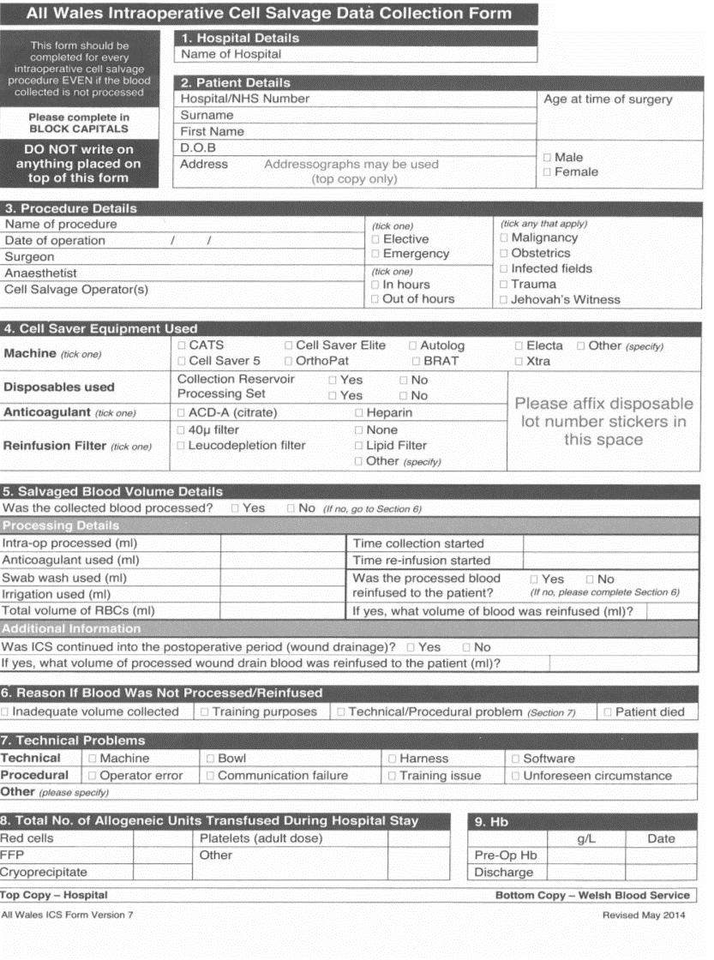
Appendix II

Intra-operative Cell Salvage Competency Assessment Workbook

The Intraoperative Cell Salvage Competency Assessment Workbook is available via the Transfusion Practice section of the JPAC website, at: www.transfusionguidelines.org.uk or for hospitals in England, the distribution hub, at: https://ww3.access-24.co.uk/Login.aspx?ReturnUrl=%2fWebSite%2fStock%2fHome%2fStock.aspx
User names and passwords are available from your RTC Administrator or NHSBT Customer Service Support Team (01865 381042).

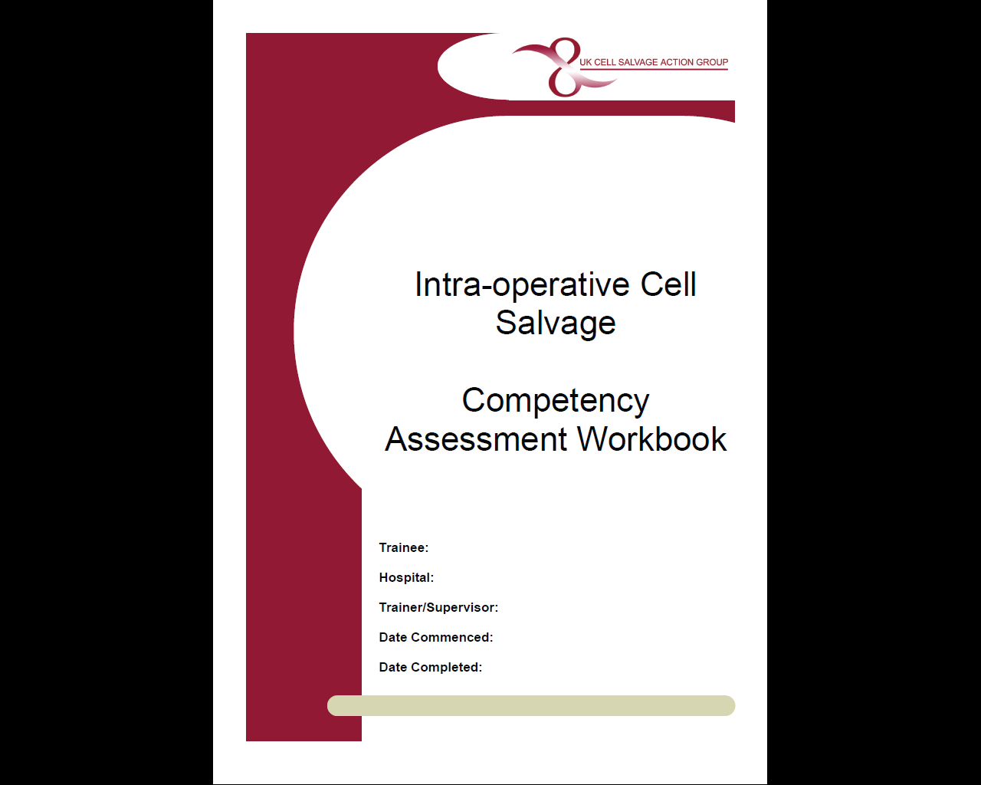

Appendix III

INTRAOPERATIVE CELL SALVAGE IN OBSTETRICS

ICS Technical Factsheet Version 8
AREA of APPLICATION

STAFF

All staff involved in the ICS process.

PROCEDURE:

The use of ICS in obstetrics has been endorsed by:

- Centre for Maternal and Child Enquiries (CMACE) (formerly CEMACH)^{2,3,4}
- Joint AAGBI/OAA Guidelines⁵
- National Institute for Health and Care Excellence (NICE)⁶

It is strongly recommended that any health care professional involved with obstetric ICS be familiar with all relevant guidelines.

- Patient Selection and Preparation

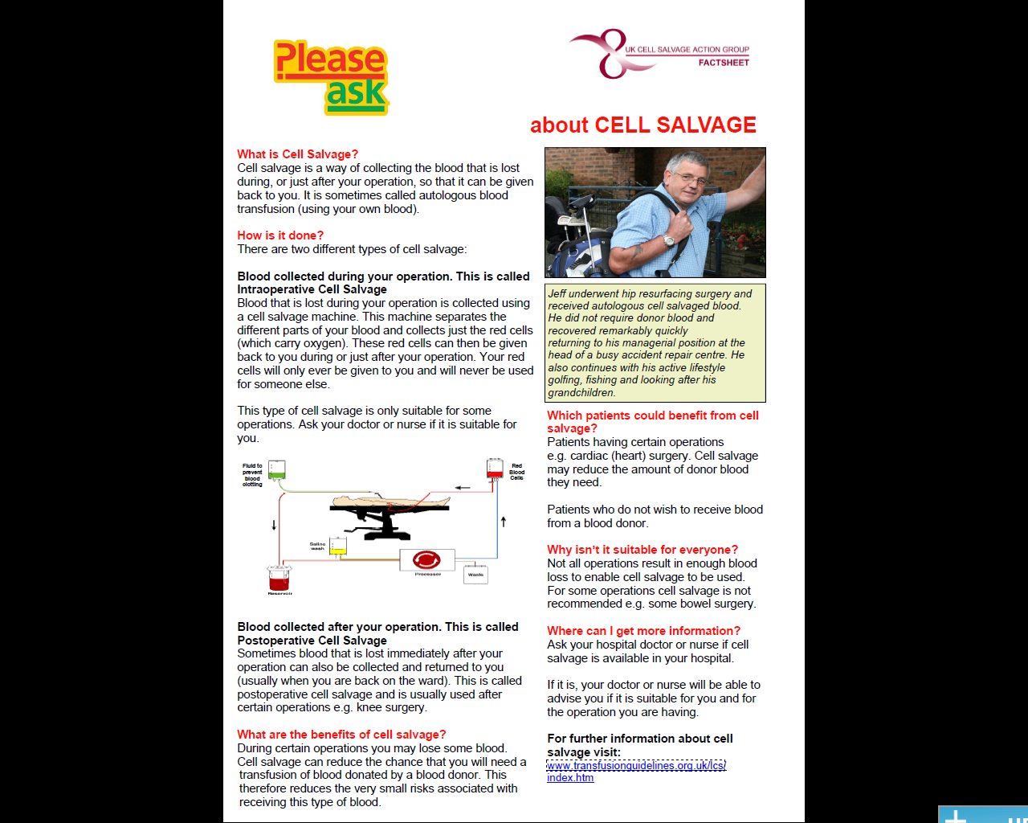

Wherever possible, the advantages and risks of ICS and allogeneic blood transfusion should be discussed with the woman prior to undergoing an obstetric surgical procedure. In a pre-planned case this can be done during pregnancy. It is recommended that women receive the NHS Blood and Transplant information leaflet entitled “Will I need a blood transfusion?”* and the UK Cell Salvage Action Group patient information leaflet entitled “Please ask about CELL SALVAGE”.

*England and North Wales only - Please contact the Welsh Blood Service, the Scottish National Blood Transfusion Service or the Northern Ireland Blood Transfusion Service to obtain the appropriate leaflet for South and Mid Wales, Scotland and Northern Ireland.

The NICE guidance “Intraoperative blood cell salvage in obstetrics” recommends that “whenever possible, the woman understands what is involved and the theoretical risks, and agrees (consents) to have the procedure”. When obtaining formal consent for a caesarean section, the obstetrician or anaesthetist should discuss the advantages and risks of ICS with the woman and document clearly her agreement to undergo the procedure. Such detailed consent may not be practicable in an emergency, in which case the use of ICS should be fully discussed with the mother following the procedure.

2. Indications for ICS

Patient selection for ICS is at the discretion of the obstetrician and anaesthetist caring for the woman. The type of obstetric cases that should be considered for selection include:

2.1 Emergency situations
- Ruptured ectopic pregnancy
- Placental abruption
- Any emergency caesarean section where there is:
- An anticipated blood loss of >1000mls
Or where any of the following are present:
- Risk factors for bleeding
- Low pre-operative Haemoglobin
- Rare blood group / multiple antibodies
- The woman has objections to receiving allogeneic blood but has consented to receiving cell salvage blood
- Surgical management of postpartum haemorrhage

2.2 Elective situations
- Women with an anticipated blood loss of >1000ml e.g. placenta accreta, large uterine fibroids, and other predictable causes of Major Obstetric Haemorrhage (MOH).
- Women who for religious or other reasons refuse allogeneic blood and have consented to the use of Intraoperative Cell Salvage in elective or emergency bleeding situations or in significant anaemia⁸

3. Additional measures necessary in obstetric ICS

3.1 Amniotic fluid and use of Leucocyte Depletion Filter
Amniotic fluid should theoretically not be aspirated into the collection reservoir, but should be removed by separate suction prior to starting cell salvage. This recommendation will reduce the initial contamination, although in vitro evidence consistently demonstrates that the cell salvage/filtration process can effectively remove plasma phase elements of amniotic fluid whatever the initial load^{7,8}. In life-threatening haemorrhage, therefore, a clinical decision to salvage red cells from the start of the procedure could be carefully considered, and is supported by current in vitro evidence. A number of hospitals in the UK have adopted the one suction approach irrespective of estimated blood loss.

To ensure efficient washing, use a quality wash programme and consider increasing the standard saline wash volume. Do not process incomplete bowls as this will compromise the washing efficiency (use “concentrate” where appropriate).

After processing, a Pall RS filter (LeukoGuard RS, Pall Biomedical Products Co., East Hills, NY) should be used to reinfuse the cell salvaged blood*. This is the only filter proved to effectively eliminate residual particulate elements of amniotic fluid⁹. It should be remembered that prior to the year 2000, this filter was not available, but over 250 cases worldwide had safely received cell-salvaged blood without a problem. This filter slows infusion rates considerably. When blood loss is rapid, the flow rate through the filter may not be sufficient to give back large volumes of blood quickly. Using a filter in each port will double the flow rate. The use of a pressure cuff is not advised due to the risk of air embolus and the unknown impact of pressure on the retention of amniotic contaminants within the filter. In life-threatening haemorrhage, however, where allogeneic blood may not be readily available or is refused, a clinical decision to remove the filter completely could be carefully considered.

*Caution: MHRA Safety Alert¹⁰
Nationally there have been an increasing number of reports regarding severe hypotension observed during reinfusion of salvaged blood when using leucodepletion filters. The MHRA produced a safety alert in January 2011 regarding the use of leucodepletion filters in cell salvage. Since this safety alert was published, a case report of severe hypotension occurring without the use of leucodepletion filter was published in the 2012 SHOT Report¹¹. The cause of the hypotensive incidents remains unknown. All such incidents should be reported to SHOT¹².

3.2 RhD immunisation and estimation of Feto Maternal Haemorrhage (FMH) (Kleihauer or Flow Cytometry)
In any pregnancy, if the mother is RhD negative and the fetus is RhD positive there is a danger of RhD immunisation if the maternal circulation is exposed to fetal red cells. Antibodies against the fetal red cells can cause haemolytic disease of the newborn in subsequent pregnancies if untreated, consequently all RhD negative women who deliver an RhD positive baby will have a FMH test performed post delivery. FMH testing is required to establish the amount of fetal red cell exposure and ensure the recipients receive an appropriate dose of anti-D immunoglobulin (usually 125 iu/ml of fetal blood). Depending on the results of this (i.e. if the baby is RhD positive) a minimum of 500iu anti-D will be given. The same protocol should apply for RhD negative women who have received salvaged red cells. If cell salvage is used in such women, exposure to fetal red cells is very likely because the cell saver centrifuge cannot distinguish fetal from maternal red cells. The sample for Kleihauer testing should be taken after the reinfusion of the ICS blood. However, due to the high risk of fetal cells mixing with the maternal circulation, an initial dose of 1500iu anti-D is recommended and depending on the test results it may be that further doses of anti-D will need to be administered. Administration of anti-D should occur within 72 hours of delivery.

It should be remembered that the risk of sensitisation to other antibodies may also be higher as a result of cell salvage being used. It has therefore been suggested that all women receiving cell salvaged blood should be followed up between 4 – 6 months post delivery to check for antibody formation, however this is not currently practicable in most centres.

REFERENCES

- Teig M, Harkness M, Catling S, Clark V. Survey of cell salvage use in obstetrics in the UK. International Journal of Obstetric Anaesthesia (2007) 16, S30
- Why Mothers Die 2000-2002 (2004) Confidential Enquiry into Maternal and Child Health (CEMACH) http://www.hqip.org.uk/assets/NCAPOP-Library/CMACE-Reports/33.-2004-Why-Mothers-Die-2000-2002-The-Sixth-Report-of-the-Confidential-Enquiries-into-Maternal-Deaths-in-the-UK.pdf
- Saving Mothers’ Lives: Reviewing maternal deaths to make motherhood safer 2003-2005 (2007) Confidential Enquiry into Maternal and Child Health (CEMACH) http://www.oaa-anaes.ac.uk/assets/_managed/editor/File/Reports/2003-2005_saving_mothers_full_report.pdf
- Saving Mothers’ Lives: Reviewing maternal deaths to make motherhood safer 2006-2008 (2011) Centre for Maternal and Child Enquiries (CMACE) http://www.oaa-anaes.ac.uk/assets/_managed/editor/File/Reports/2006-2008%20CEMD.pdf
- The Association of Anaesthetists of Great Britain and Ireland Obstetric Anaesthetists’ Association. Guidelines for Obstetric Anaesthetic Services Revised Edition 2005, p25 http://www.aagbi.org/sites/default/files/obstetric05.pdf
- National Institute for Health & Care Excellence. 2005. Guideline IPG144: Intraoperative blood cell salvage in obstetrics (issued November 2005). Available from: http://www.nice.org.uk/nicemedia/live/11038/30690/30690.pdf
- Catling SJ Williams S. Fielding AM. (1999) Cell salvage in obstetrics: an evaluation of the ability of cell salvage combined with leucocyte depletion filtration to remove amniotic fluid from operative blood loss at caesarean section. Int J Obs Anesth; 8; 79 84.
- Sullivan I, Faulds J, Ralph C. Contamination of salvaged maternal blood by amniotic fluid and fetal red cells during elective Caesarian section. Br J Anaesth 2008 ;101:225-229
- Waters JH. Biscotti C. Potter PS. Phillipson E. (2000) Amniotic Fluid Removal During Cell Salvage in the Caesarean Section Patient. Anaesthesiology; 92; 1531 1536.
- by amniotic fluid and fetal red cells during elective Caesarian section. Br J Anaesth 2008 ;101:225-229
- Waters JH. Biscotti C. Potter PS. Phillipson E. (2000) Amniotic Fluid Removal During Cell Salvage in the Caesarean Section Patient. Anaesthesiology; 92; 1531 1536.

- MHRA Safety Alert (2011) One Liners (Issue 82) http://www.mhra.gov.uk/Publications/Safetyguidance/OneLiners/CON105973
- SHOT Report (2012) http://www.shotuk.org/shot-reports/report-summary-and-supplement-2012/
- Serious Hazards of Transfusion (SHOT) http://www.shotuk.org/sabre/

Appendix IV

“Cell Salvage” Patient Information Leaflet

The following patient information leaflet can be downloaded at:
http://www.transfusionguidelines.org.uk/transfusion-practice/uk-cell-salvage-action-group/patient-factsheet

Appendix V

Manufacturers’ Guidelines

The organisation should attach a copy of the Manufacturers’ guidelines to this section.
Appendix VI

Autologous Transfusion Label

The following autologous transfusion label is available from your device manufacturer. N.B. cable ties or equivalents are not provided.

Appendix VII

Fault log

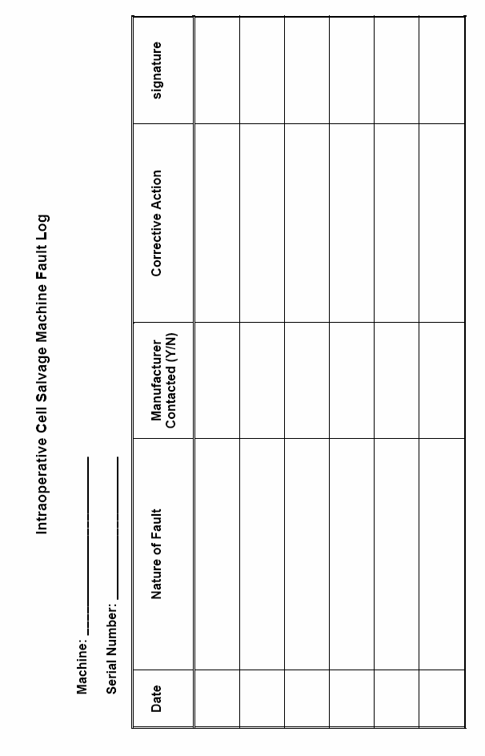
Appendix VIII

NHS Blood and Transplant information leaflets

“Will I need a blood transfusion?”

These information leaflets can be ordered from: https://hospital.nhsbtleaflets.co.uk/
Alternatively the leaflets can be downloaded at:
http://hospital.blood.co.uk/patient-services/patient-blood-management/patient-information-leaflets/

“Will your child need a blood transfusion?”

NB. These leaflets are for hospitals supplied by NHS blood and Transplant, hospitals in Wales, Scotland and Northern Ireland should contact their local blood service for the equivalent leaflet.

